SAP ID: 60004190057

**NAME: JUNAID GIRKAR DIVISION: SE A (COMPS)**

**Experiment No-2 Aim:**Mapping ER/EER to Relational schema model.

**Theory:**

**Step 1:**Mapping of Regular Entity Types.

For each regular (strong) entity type E in the ER schema, create a                                                                                                   relation R that includes all the simple attributes of E.

Choose one of the key attributes of E as the primary key for R. If the chosen key of E is composite, the set of simple attributes that form it will together form the primary key of R.

**Step 2:**Mapping of Weak Entity Types

For each weak entity type W in the ER schema with owner entity type E, create a relation R and include all simple attributes (or simple components of composite attributes) of W as attributes of R.

In addition, include as foreign key attributes of R the primary key attribute(s) of the relation(s) that correspond to the owner entity type(s).

The primary key of R is the *combination of*the primary key(s) of the owner(s) and the partial key of the weak entity type W, if any.

**Step 3:**Mapping of Binary 1:1 Relation Types

For each binary 1:1 relationship type R in the ER schema, identify the relations S and T that correspond to the entity types participating in R. There are three possible approaches:

Foreign Key approach: Choose one of the relations-S, say-and include a foreign key in S the primary key of T. It is better to choose an entity type with *total participation*in R in the role of S.

Merged relation option: An alternate mapping of a 1:1 relationship type is possible by merging the two entity types and the relationship into a single relation. This may be appropriate when *both participations are total.*

Cross-reference or relationship relation option: The third alternative is to set up a third relation R for the purpose of cross-referencing the primary keys of the two relations S and T representing the entity types.

**Step 4:**Mapping of Binary 1:N Relationship Types.

For each regular binary 1:N relationship type R, identify the relation S that represent the participating entity type at the N-side of the relationship type.

Include as foreign key in S the primary key of the relation T that represents the other entity type participating in R.

Include any simple attributes of the 1:N relation type as attributes of S.

**Step 5:**Mapping of Binary M:N Relationship Types.

For each regular binary M:N relationship type R, *create a new relation*S to represent R.

Include as foreign key attributes in S the primary keys of the relations that represent the participating entity types; *their combination will form the primary key*of S.

Also include any simple attributes of the M:N relationship type (or simple components of composite attributes) as attributes of S.

**Step 6:**Mapping of Multivalued attributes.

For each multivalued attribute A, create a new relation R. This relation R will include an attribute corresponding to A, plus the primary key attribute K-as a foreign key in R-of the relation that represents the entity type of relationship type that has A as an attribute.

The primary key of R is the combination of A and K. If the multivalued attribute is composite, we include its simple components.

**Step 7:**Mapping Specialization or Generalization.

Convert each specialization with m subclasses {S1, S2,….,Sm} and generalized superclass C, where the attributes of C are {k,a1,…an} and k is the (primary) key, into relational schemas using one of the four following options:

**Option 8A:**Multiple relations-Superclass and subclasses.

Create a relation L for C with attributes Attrs(L) = {k,a1,…an} and PK(L) = k. Create a relation Li for each subclass Si, 1 < i < m, with the attributesAttrs(Li) = {k} U

{attributes of Si} and PK(Li)=k. This option works for any specialization (total or partial, disjoint of over-lapping).

**Option 8B:**Multiple relations-Subclass relations only

Create a relation Li for each subclass Si, 1 < i < m, with the attributes Attr(Li) =

{attributes of Si} U {k,a1…,an} and PK(Li) = k. This option only works for a specialization whose subclasses are total (every entity in the superclass must belong to (at least) one of the subclasses).

**Option 8C:**Single relation with one type attribute.

Create a single relation L with attributes Attrs(L) = {k,a1,…an} U {attributes of S1} U…U {attributes of Sm} U {t} and PK(L) = k. The attribute t is called a type (or discriminating) attribute that indicates the subclass to which each tuple belongs(Disjoint)

**Option 8D:**Single relation with multiple type attributes.

Create a single relation schema L with attributes Attrs(L) = {k,a1,…an} U {attributes of S1} U…U {attributes of Sm} U {t1, t2,…,tm} and PK(L) = k. Each ti, 1 < I < m, is a Boolean type attribute indicating whether a tuple belongs to the subclass Si.(Overlap)

|  |  |
| --- | --- |
|  |  |

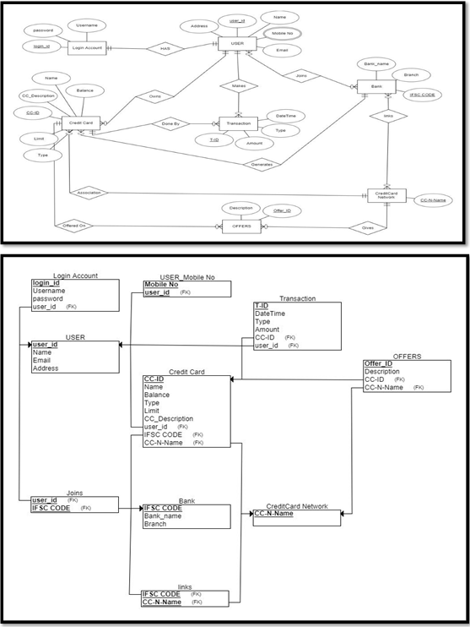

Conclusion: By applying conversion process we converted **Entity Relationship/EER Modeling**to relational schema.